**ARMY PUBLIC SCHOOL ALLAHABAD**



**ACADEMIC YEAR: 2021-22**

**PROJECT REPORT ON**

**LIBRARY MANGEMENT PROGRAM**

**CLASS : XII**

**SUBJECT : COMPUTER SCIENCE**

**SUB CODE : 083**

**PROJECT GUIDE:** **Mrs Smita Verma**

**PGT (CS)**

**ARMY PUBLIC SCHOOL ALLAHABADNEW CANTT**

**PRAYAGRAJ**

**MEMBERS : HIMANSHU MISHRA (10)**

**RAMJEE (18)**

**SANDEEP KUMAR (19)**

**ARMY PUBLIC SCHOOL ALLAHABAD**



**CERTIFICATE**

This is to certify that Master ____________________ CBSE Roll No:_________________ has successfully completed the project Work entitled **LIBRARY MANGEMENT PROGRAM** in the subject Computer Science (083) laid down in the regulations of CBSE for the purpose of Practical Examination in Class XII to be held in Army Public School Allahabad on______________.

**(Smita Verma)**

PGT Computer science

**Signature of External Examiner**

Name: - _________________ Examiner Number:-______________

|  |  |  |
| --- | --- | --- |
| **TABLE OF CONTENTS** | | |
| **S.NO** | **DESCRIPTION** | **P. NO** |
| 01 | ACKNOWLEDGEMENT | **04** |
| 02 | INTRODUCTION | **05** |
| 03 | OBJECTIVES OF THE PROJECT | **05** |
| 04 | PROPOSED SYSTEM | **06** |
| 05 | SYSTEM DEVELOPMENT LIFE CYCLE (SDLC) | **06** |
| 06 | PHASES OF SYSTEM DEVELOPMENT LIFE CYCLE | **07** |
| 07 | FLOW CHART | **09** |
| 09 | OUTPUTS OF PROGRAM | **10** |
| 10 | INSTALLATION FILE | **13** |
| 11 | HARDWARE AND SOFTWARE REQUIREMENTS | **14** |
| 12 | BIBLIOGRAPHY | **15** |

**ACKNOWLEDGEMENT**

Apart from the efforts of me, the success of any project depends largely on the encouragement and guidelines of many others. I take this opportunity to express my gratitude to the people who have been instrumental in the successful completion of this project. I express my deep sense of gratitude to the luminary **The Principal**, Army Public School Allahabad who has been continuously motivating and extending their helping hand to us.

I am overwhelmed to express my thanks to The **Administrative Officer** for providing me an infrastructure and moral support while carrying out this project in the school. My sincere thanks to **Mrs Smita Verma**, A guide, Mentor all the above a friend, who critically reviewed my project and helped in solving each and every problem, occurred during implementation of the project

The guidance and support received from all the members who contributed and who are contributing to this project, was vital for the success of the project. I am grateful for their constant support and help.

**PROJECT ON LIBRARY MANGEMENT PROGRAM**

**INTRODUCTION**

This project is all about software for LIBRARY MANGEMENT PROGRAM. It helps to have a full-fledged support to universities as well as school’s libraries. The project is divided into 2 sections to make the programme easy to understand. It receives user name and password to log in and register .It keeps the record of at what time book is rented, to whom, his identity, and whether he had returned it or it is due.

**OBJECTIVES OF THE PROJECT**

The objective of this project is to let the students apply the programming knowledge into a real- world situation/problem and exposed the students how programming skills helps in developing a good software.

1. Write programs utilizing modern software tools.
2. Write effective procedural code to solve small to medium sized problems.
3. Students will demonstrate a breadth of knowledge in computer science, as exemplified in the areas of systems, theory and software development.
4. Students will demonstrate ability to conduct a research or applied Computer Science project, requiring writing and presentation skills which exemplify scholarly style in computer science.

PROPOSED SYSTEM

Today one cannot afford to rely on the fallible human beings of be really wants to stand against today’s merciless competition where not to wise saying **“to err is human”** no longer valid, it’s outdated to rationalize your mistake. So, to keep pace with time, to bring about the best result without malfunctioning and greater efficiency so to replace the unending heaps of flies with a much sophisticated hard disk of the computer. Many software products working are now in markets, which have helped in making the organizations work easier and efficiently. Data management initially had to maintain a lot of ledgers and a lot of paper work has to be done but now software product on this organization has made their work faster and easier. Now only this software has to be loaded on the computer and work can be done.

This prevents a lot of time and money. The work becomes fully automated and any information regarding the organization can be obtained by clicking the button. Moreover, now it’s an age of computers of and automating such an organization gives the better look.

**SYSTEM DEVELOPMENT LIFE CYCLE (SDLC)**

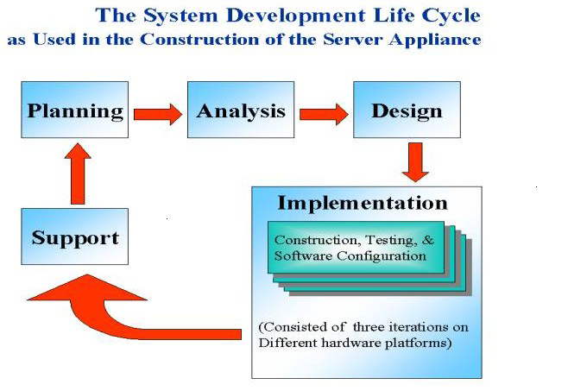

The systems development life cycle is a project management technique that divides complex projects into smaller, more easily managed segments or phases. Segmenting projects allows managers to verify the successful completion of project phases before allocating resources to subsequent phases.

**PHASES OF SYSTEM DEVELOPMENT LIFE CYCLE**

Systems development life cycle phases include planning, system analysis, system design, development, implementation, integration and testing, and operations and maintenance.

**1.   Initiation Phase**

The initiation of a system (or project) begins when a business need or opportunity is identified. A Project Manager should be appointed to manage the project. This business need is documented in a Concept Proposal. After the Concept Proposal is approved, the System Concept Development Phase begins.

**2.  System Concept Development Phase**

Once a business need is approved, the approaches for accomplishing the concept are reviewed for feasibility and appropriateness. The Systems Boundary Document identifies the scope of the system and requires Senior Official approval and funding before beginning the Planning Phase.

**3. Planning Phase**

The concept is further developed to describe how the business will operate once the approved system is implemented, and to assess how the system will impact employee and customer privacy. To ensure the products and / or services provide the required capability on-time and within budget, project resources, activities, schedules, tools, and reviews are defined. Additionally, security certification and accreditation activities begin with the identification of system security requirements and the completion of a high level vulnerability assessment.

**4. Requirements Analysis Phase**

Functional user requirements are formally defined and delineate the requirements in terms of data, system performance, security, and maintainability requirements for the system. All requirements are defined to a level of detail sufficient for systems design to proceed. All requirements need to be measurable and testable and relate to the business need or opportunity identified in the Initiation Phase.

**5. Design Phase**

The physical characteristics of the system are designed during this phase. The operating environment is established, major subsystems and their inputs and outputs are defined, and processes are allocated to resources. Everything requiring user input or approval must be documented and reviewed by the user. The physical characteristics of the system are specified and a detailed design is prepared. Subsystems identified during design are used to create a detailed structure of the system. Each subsystem is partitioned into one or more design units or modules. Detailed logic specifications are prepared for each software module.

**6**. **Development Phase**

The detailed specifications produced during the design phase are translated into hardware, communications, and executable software. Software shall be unit tested, integrated, and retested in a systematic manner. Hardware is assembled and tested.

**7. Testing Phase**

The various components of the system are integrated and systematically tested. The user tests the system to ensure that the functional requirements, as defined in the functional requirements document, are satisfied by the developed or modified system. Prior to installing and operating the system in a production environment, the system must undergo certification and accreditation activities.

**8. Implementation Phase**

The system or system modifications are installed and made operational in a production environment. The phase is initiated after the system has been tested and accepted by the user. This phase continues until the system is operating in production in accordance with the defined user requirements.

**9. Operations and Maintenance Phase**

The system operation is ongoing. The system is monitored for continued performance in accordance with user requirements, and needed system modifications are incorporated. The operational system is periodically assessed through In-Process Reviews to determine how the system can be made more efficient and effective. Operations continue as long as the system can be effectively adapted to respond to an organization’s needs. When modifications or changes are identified as necessary, the system may reenter the planning phase.

**10. Disposition Phase**

The disposition activities ensure the orderly termination of the system and preserve the vital information about the system so that some or all of the information may be reactivated in the future if necessary. Particular emphasis is given to proper preservation of the data processed by the system, so that the data is effectively migrated to another system or archived in accordance with applicable records management regulations and policies, for potential future access.

**FLOW CHART**

Input password

Is password _correct

**FALSE**

**TRUE**

Input choice (1-6)

If choice is between (1 – 6)

**FALSE**

**TRUE**

FALSE

FALSE

FALSE

FALSE

FALSE

**If 6**

**If 5**

**If 4**

**If 3**

**If 2**

**If 1**

TRUE

TRUE

TRUE

TRUE

TRUE

TRUE

PRINT RECORDS

ADDING BOOK

RETURN BOOK

credit

ISSUE BOOK

Thank you

**OUTPUT**

**Table structure**

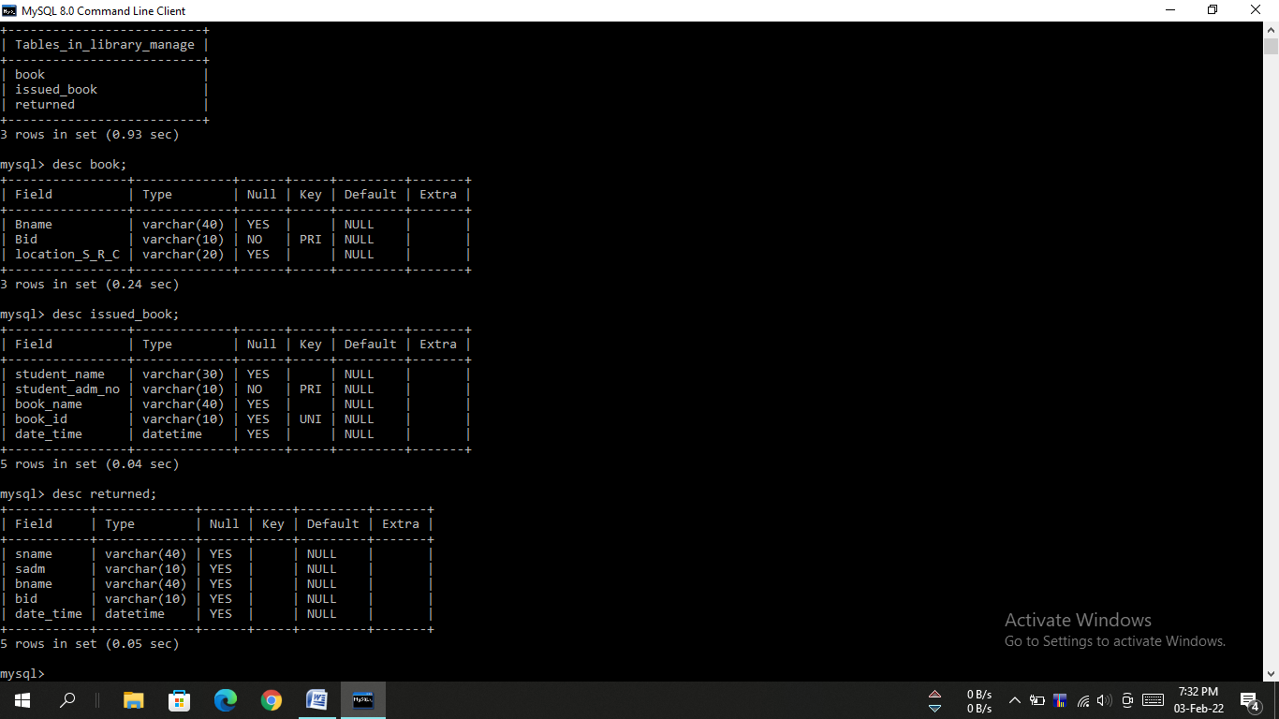

**TRYING TO VALIDATE USER** 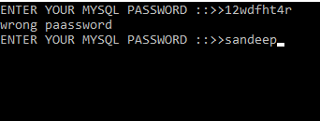

**SHOWING THE MAIN ME** 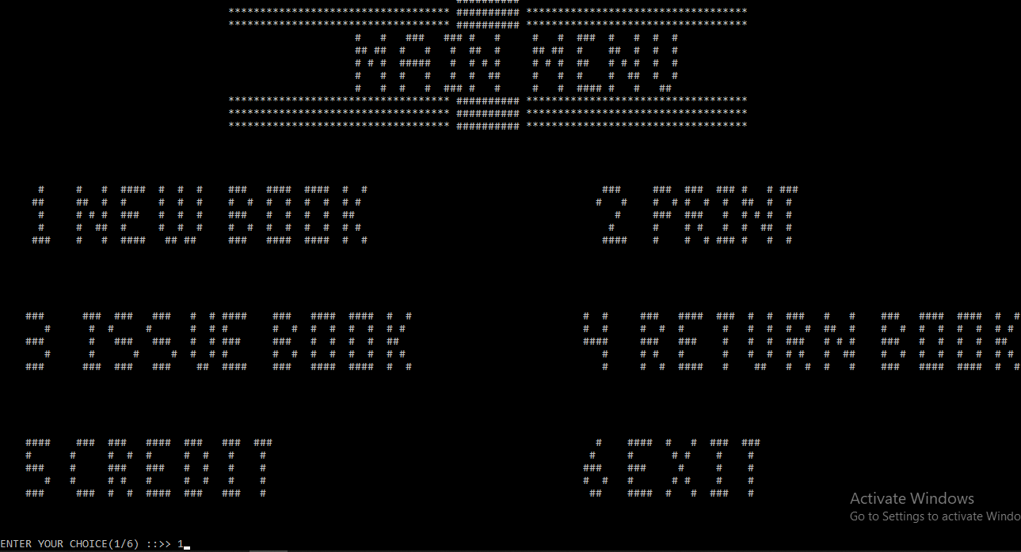

**1:- UPDATING THE BOOK COLLECTION**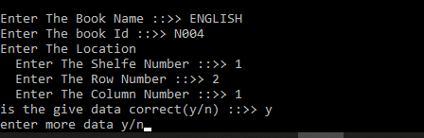

**2:- PRINTING ALL INFORMATIOM** 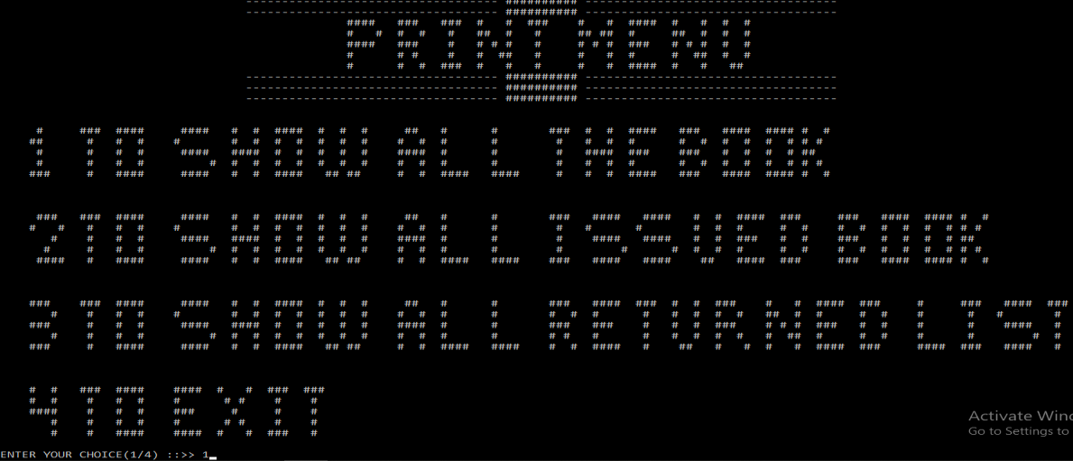

**3:- ISSUING BOOK** 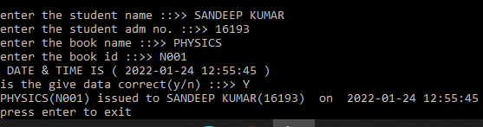

**4:- RETURNING BOOK**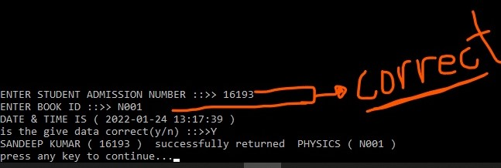

**5:- Credit**

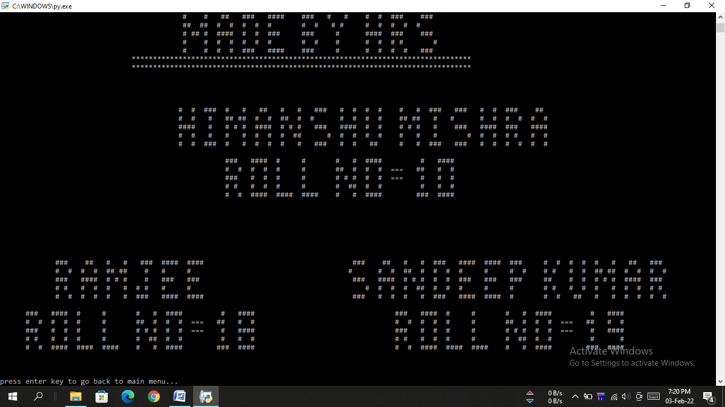

**6:- Exiting**

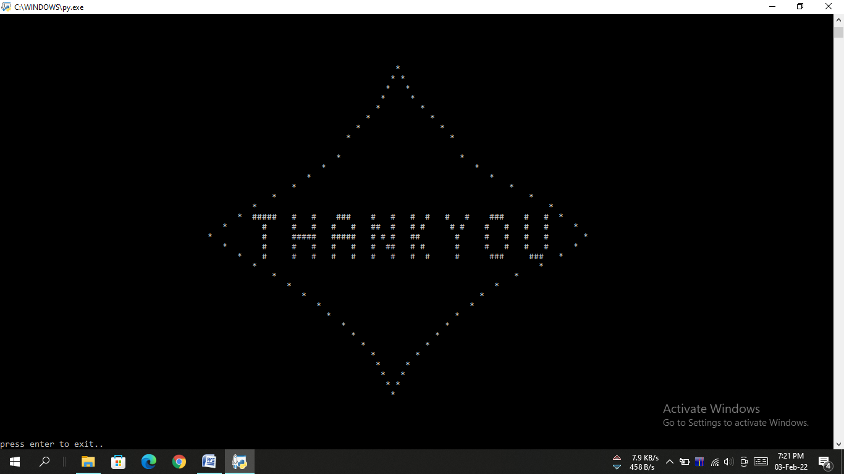

**INSTALLATION PROCEDURE**

LIBRARY MANGEMENT PROGRAM:-

-------------------------------------

Pre-Requisites:-

------------------------

**1**. You have to have the following software for the successful running of this software; which are

I) MySQL (Only for the First time), it is downloadable from 'www.mysql.org'.

II) Python, it is downloadable from ‘www.python.org’

III) Mysql.connector....pip install MySQL-connector-python

Installation:-

------------------------

1. There will be one folder namely ‘LIBRARY MANAGEMET’

2. The folder ‘LIBRARY MANAGMENT’ will contain the ‘SOURCE CODE FOLDER’ and ‘DIRECT RUN FOLDER’

3. If you want to see the source code then you can check ‘SOURCE CODE FOLDER’.

4. If you want to run the program then you can directly run the ‘main.exe’ program from ‘DIRECT RUN FOLDER’. It will automatically run you program.

5. The ‘main.exe’ file will ask for your MySQL password after that you can start working on it.

**HARDWARE AND SOFTWARE REQUIREMENTS**

**HARDWARE REQUIREMENTS**

I. OPERATING SYSTEM : WINDOWS 7 AND ABOVE

II. RAM : 512 MB+

III. Hard disk : SATA 40 GB OR ABOVE

IV. Key board and mouse

**SOFTWARE REQUIREMENTS**

1. Windows OS
2. Python
3. MySQL

.

**BIBLIOGRAPHY**

1. ***Computer science With Python - Class XII By : Sumita Arora***
2. ***Internet***